Day 2: Gratitude
Gratitude is such a powerful tool we can use to enhance our lives. The more grateful you are the more you receive to be grateful for!
Task 1: Find/make/create a gratitude jar/tub/glass. It can be anything from an empty jam jar to a beautifully crafted gratitude tub. Preferably this would be see-through gratitude container of sorts. Then find a bag of rice/beans/beads or any small pieces that you have multiples of and place both the jar and bag in a nice place in your home. When you have this done I invite you to pick up a piece, hold it in your hand and think of something you are truly grateful for.
Feel the gratitude and then place it in your gratitude jar. Repeat this 10 times! <3
Below are pictures of two I have done with my daughter Harmony:
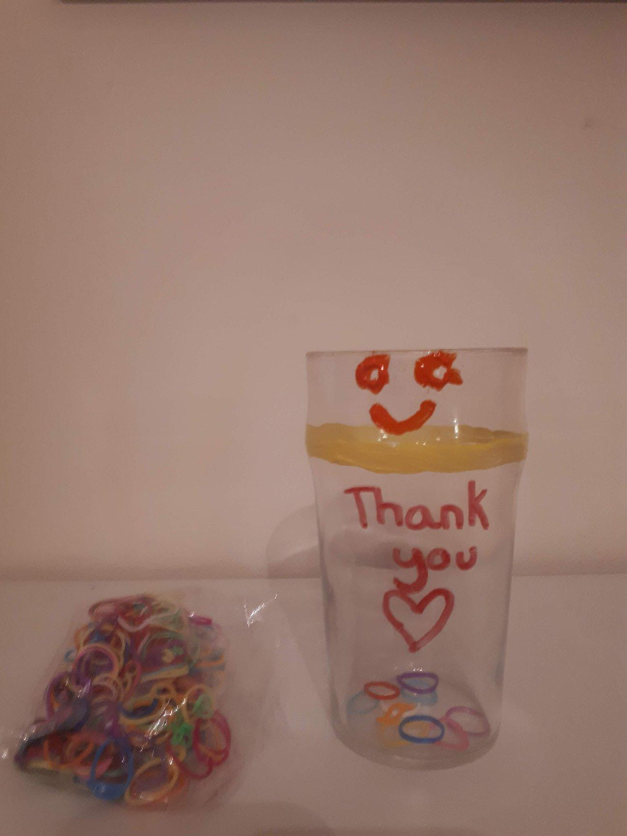
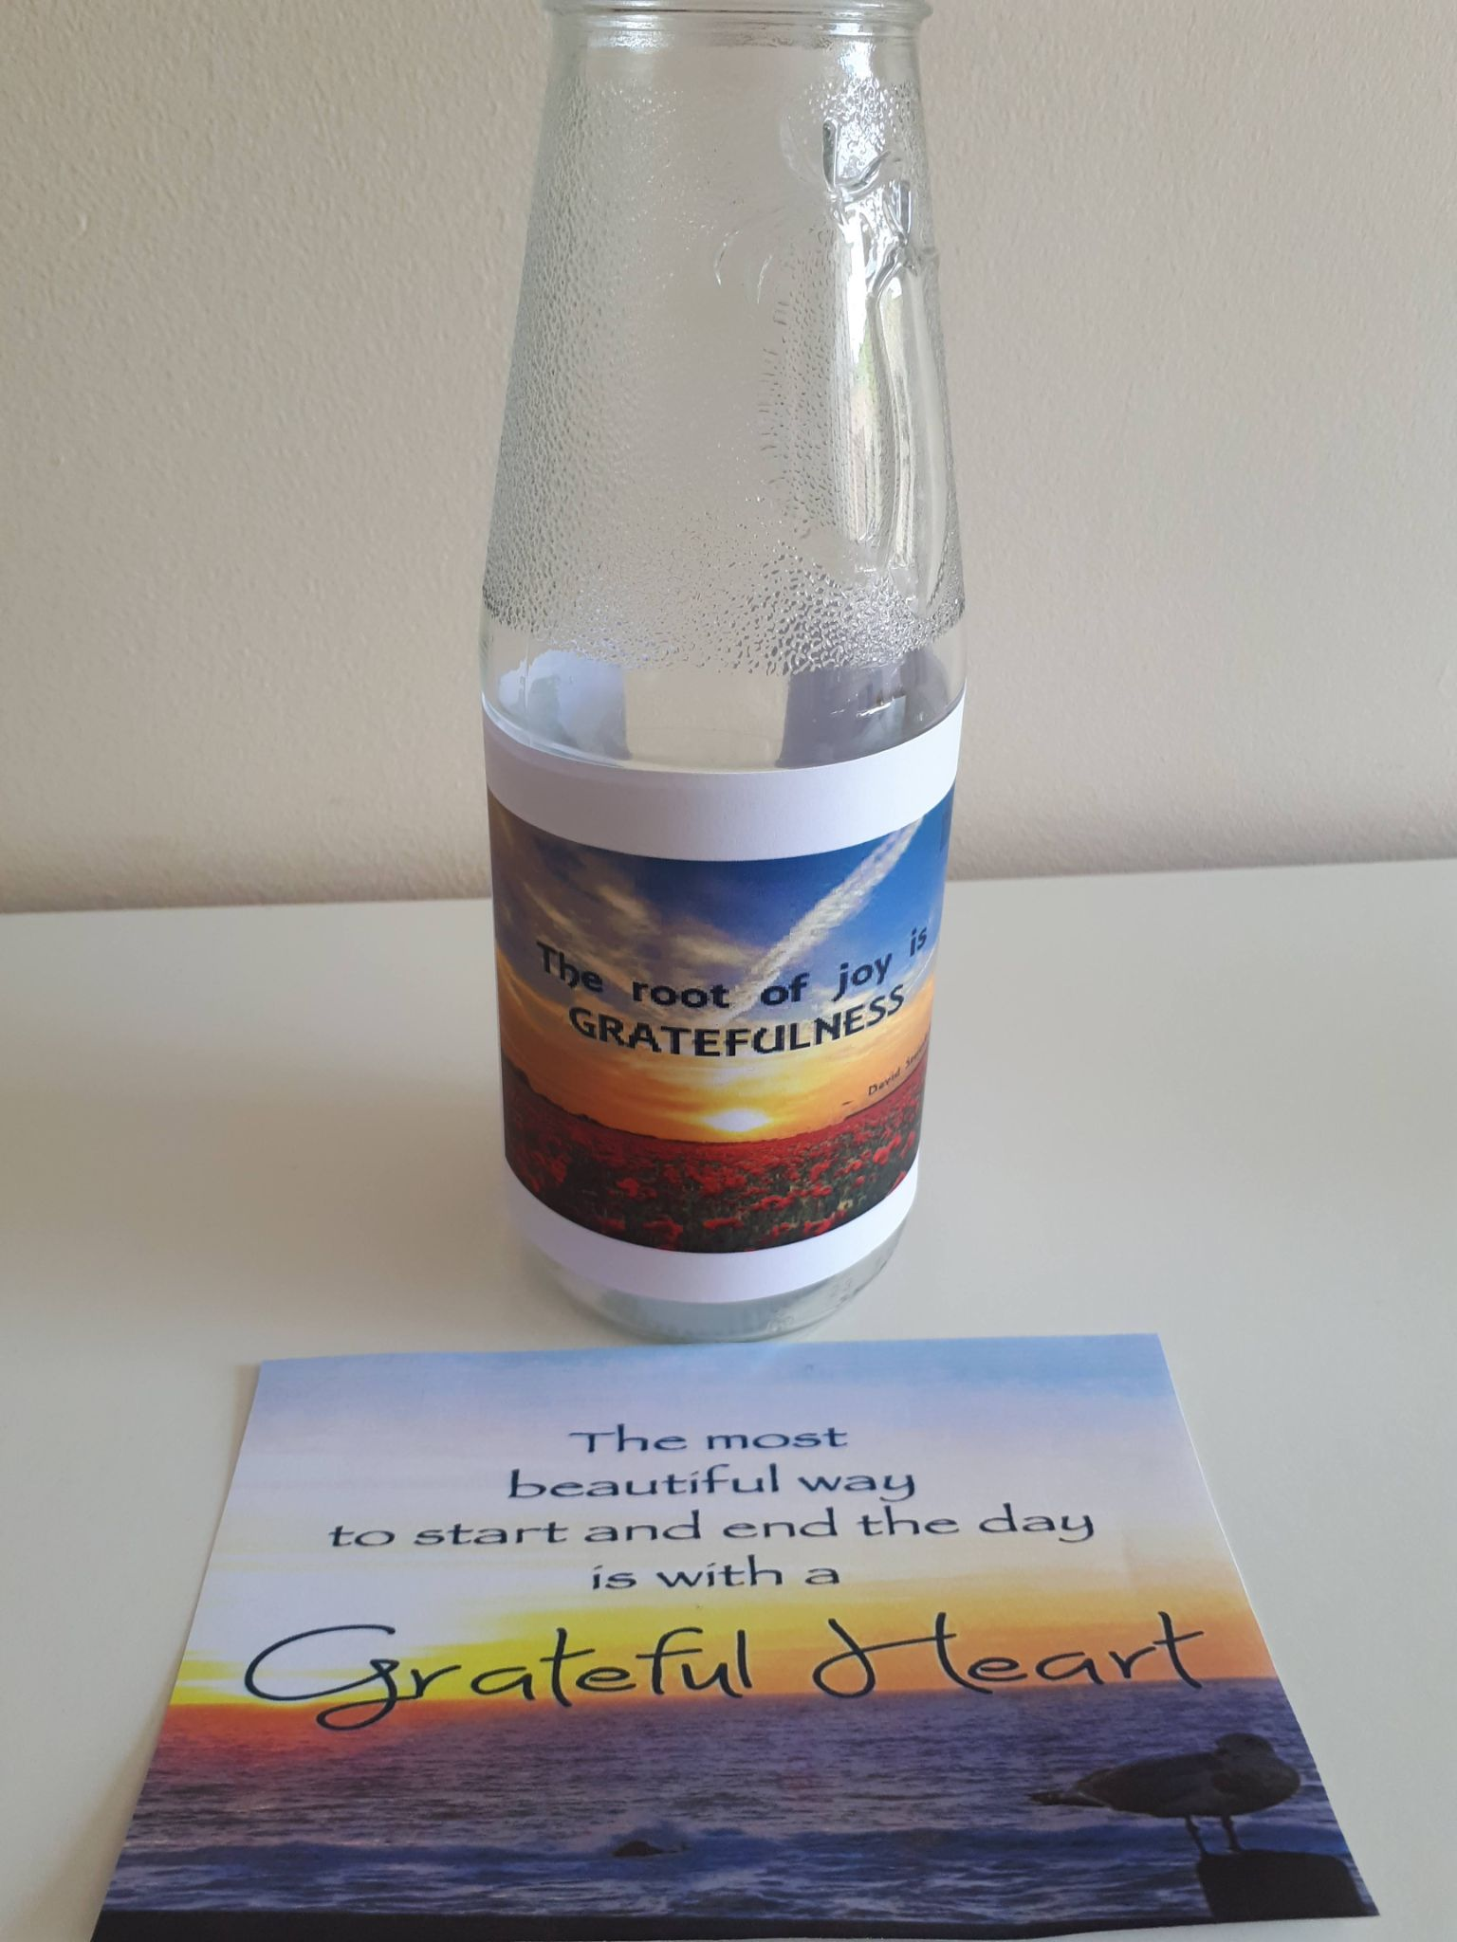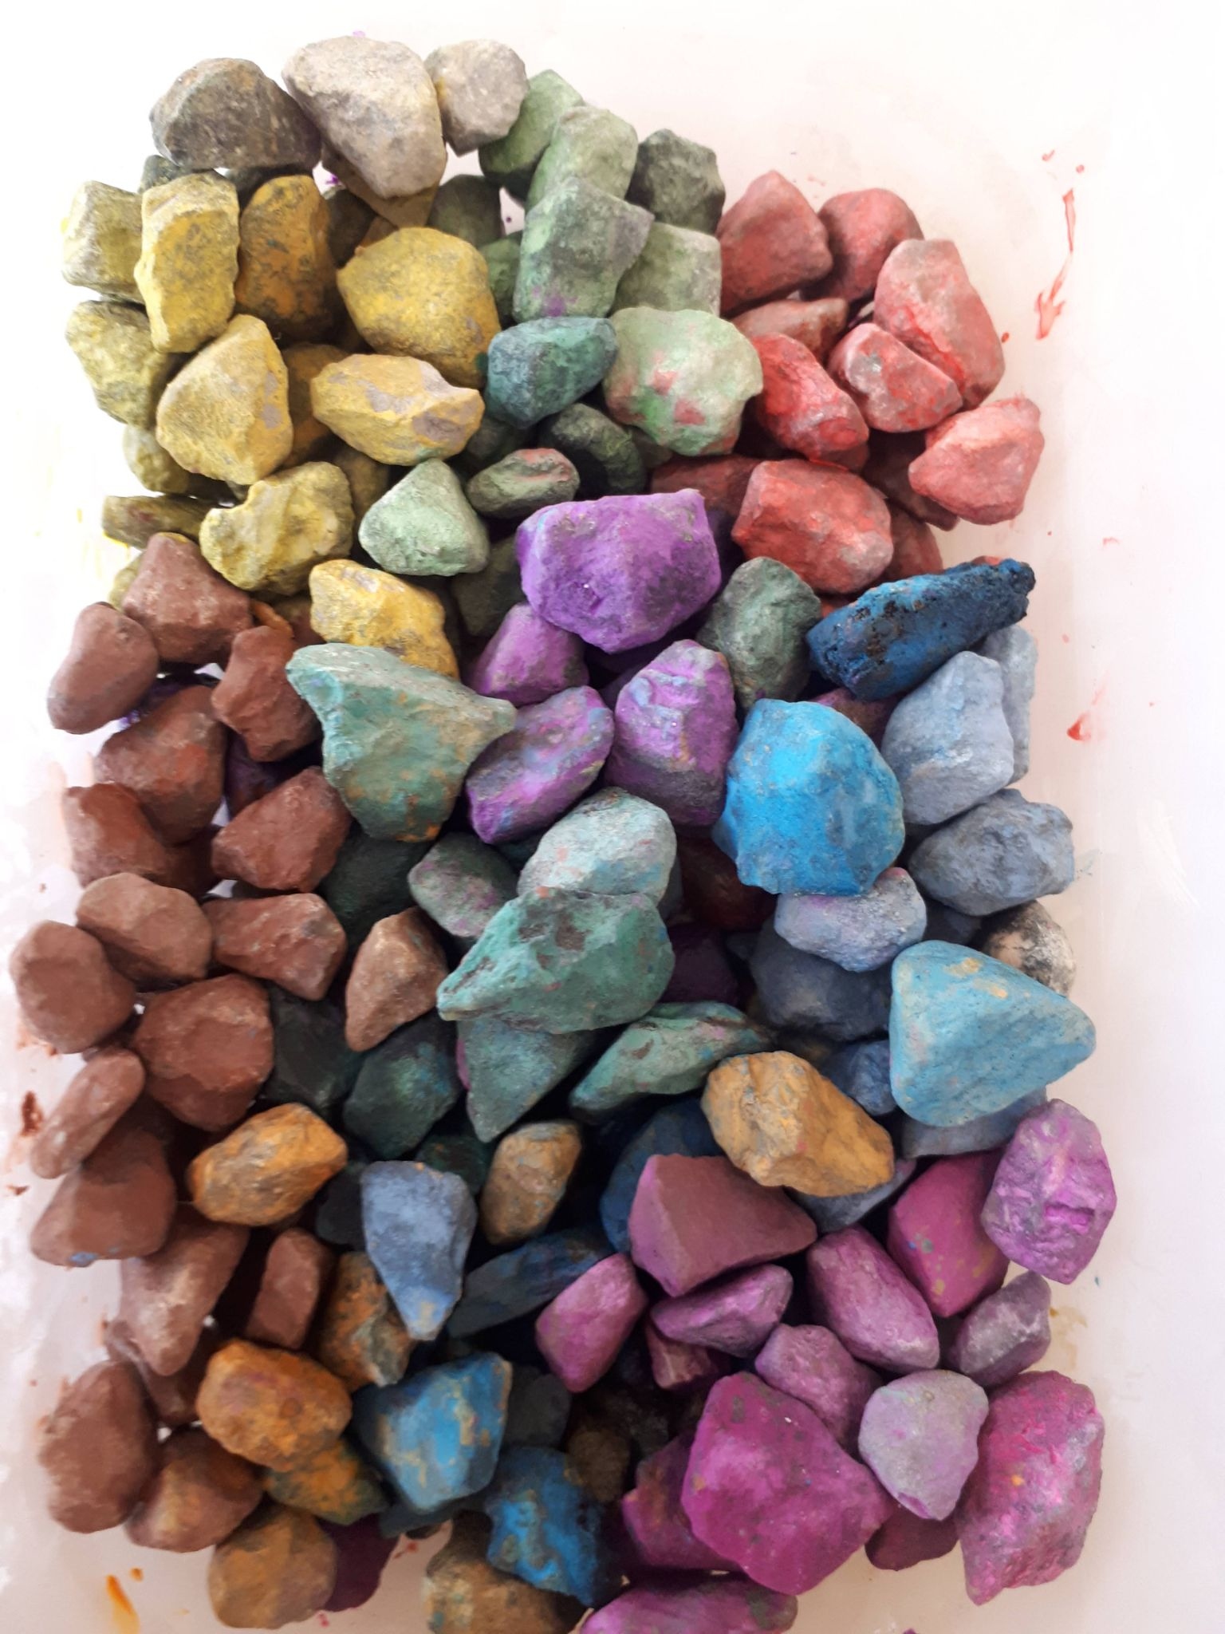

Task 2: Now I invite you to write yourself a gratitude letter. Self-love is so important and it can often take a back seat, write yourself a letter…..you deserve it!
In this letter focus on all the wonderful things that you love about yourself. Thank yourself for all that you are and all that you do!
This might feel strange and you might feel a lot of resistance to doing this but push through. You will feel wonderful afterwards!

Task 3: When feeling off, go to the gratitude jar and do 2 or more pieces of gratitude. This will help to uplift you!

“Be thankful for what you have; you’ll end up having more. If you concentrate on what you don’t have, you will never, ever have enough.”
- Oprah Winfrey

